Press Release July 10, 2013

LED Linear awarded „Innovator of the Year 2013“
Neukirchen-Vluyn/Berlin – The start-up company was being awarded the sought-after Top 100 award by a high class jury made up of Germany's best known business managers, university professors and entrepreneurs including renowned business consultant Prof. Dr. Roland Berger.
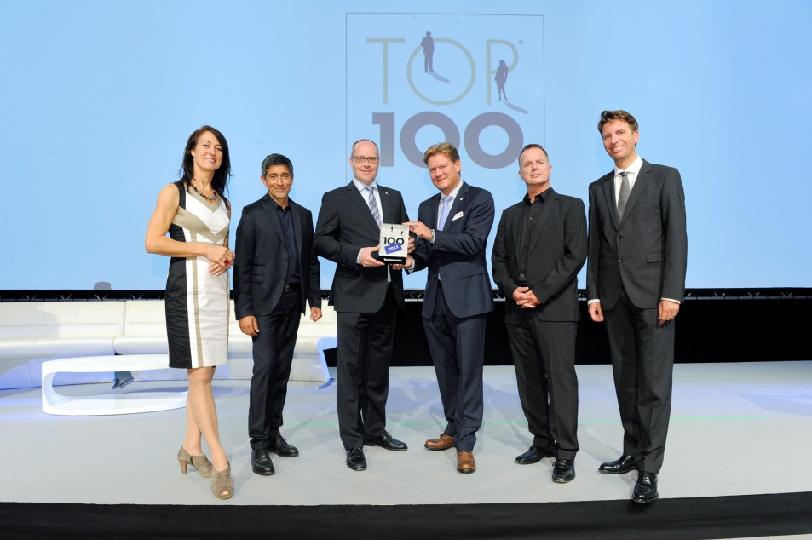
Last Friday the LED Linear GmbH was being awarded the “Innovator of the Year 2013” award by the TOP 100 jury during a festive occasion in Berlin. That makes LED Linear one of the Top Three German innovators in 2013. The jury, made up of Germany's best known business managers, university professors and entrepreneurs including renowned business consultant Prof. Dr. Roland Berger had been convinced by the rapid and spectacular development of the company’s turnover. Founded in 2006, the company showed a growth in sales of 700% between 2008 and 2012 and a growth of 730% in the total number of employees which is even more impressive as the company only consisted of a total number of 6 employees in 2009. But growth won’t stop: Since participating in the “TOP 100” survey, the company’s number of employees has risen from 50 to 70 in the meantime.
The company from the lower Rhine manufactures LED technology for the world market since 2006. It is nowadays not possible to imagine the market for luminaires without LED Linear’s innovative linear lamps and fixtures. In the fields of quality, design and look and feel, LED Linear has set new standards. The high standards applied to providing high-quality products in terms of shape and function at reasonable prices is being reflected by numerous and prestigious design and innovation awards - all under the quality seal “Made in Germany”.
Jury-member Manfred Gotta emphasizes: “The company’s history almost sounds like an economic fairy tale: from a garage company to strongly developing driver of innovation. The company’s convincing strategic master plan and the company’s founder’s distinctive entrepreneurial thinking, but also the methodological competence and a large network of innovative partners have made this fairy tale come true. LED Linear can be considered as one of the active shapers of a fast changing market.”
“We are proud of having achieved through our employees a market share with an export ratio up to 80% within a very few years with a brand which is both innovative and strong in design.” explains managing director Dr. Michael Kramer. Additionally the top-management works closely together with the heads of departments and a selection of business partners to further develop product ideas. This is reflected in 25% of 2012’s turnover being achieved with new product releases.
The Top 100 award is based on academic research on the firm conducted by Professor Nikolaus Franke and his team from the Institute for Entrepreneurship and Innovation at the Vienna University of Economics and Business. This year these innovation experts have examined a total of 245 companies. The findings of this research are made available to the participating firms in the form of a benchmarking report that reveals their potential and provides practical tips that can be applied immediately. Managing director Carsten Schaffarz: “This success is the result of a dedicated team performance of management and staff and shows that we are heading in the right direction. We will use those results to further optimize our innovation management.”
In addition to LED Linear, a further 102 firms in a total of three categories based on size will be receiving the Top 100 award. They include 51 German market leaders and 21 global market leaders. Roughly two-thirds of these firms are family-owned businesses. All of these companies together generated a total revenue of approximately €13.5 billion in 2012. The Top 100 leading innovators reinvested around 10 per cent of this revenue directly in research and development, whereas German small and medium-sized enterprises in aggregate spent only 1.4 per cent on R&D. Consequently, the award-winning firms are more successful: they generate 42.6 per cent of their revenue from products and services that they have only brought to market in the last three years, while the corresponding figure for German SMEs as a whole is a much lower 8.9 per cent. This has meant that 86 of the Top 100 firms (83.5 per cent) have generated growth that has outperformed the respective industry average – by almost 15 percentage points on average – over the past three years.

Mentor
The project's mentor is the journalist and television presenter Ranga Yogeshwar.
Project management and partners
Since 2002 this project has been managed by Professor Nikolaus Franke from the Institute for Entrepreneurship and Innovation at the Vienna University of Economics and Business. The focus of his research is on entrepreneurship, innovations management and marketing. He is one of the world's leading experts in the field of user innovation. The Fraunhofer Society for the Promotion of Applied Research is acting as the Top 100 project partner and the Süddeutsche Zeitung newspaper is the media partner.
Organiser: compamedia – mentor to the best SMEs
compamedia GmbH was founded in 1993 and has a team of 19 employees who organise the Top 100, Top Job and Top Consultant competitions for German SMEs. It also launched the Ethics in Business initiative. It supports and awards prizes to small and medium-sized firms for outstanding achievements in the fields of innovation, human resources management, consulting and corporate social responsibility. compamedia works closely with leading universities on these projects.
LED Linear
LED Linear develops and manufactures high quality linear lighting systems based on LED for technically sophisticated interior and exterior lighting. Main products are linear and scalable lighting modules and systems based on LED and with an ingress protection from IP00 up to IP68.
The product portfolio consists of various lighting systems, which have been nominated for and granted prestigious international design awards. On the basis of the modular LED tool kit more than 2,5 million lighting fixtures can be build. Thus specific and individual custom solutions can be generated.
LED Linear lighting systems are used in applications varying from mood lighting to general lighting in office spaces, from under cabinet lighting up to façade lighting in 300 meter heights. The use of high quality and long living components warrant energy savings and sustainable lighting solutions with a long life time of over 50.000hrs. LED Linear products are lead free soldered and RoHS compliant. VarioLED™, xoolum™, xoolux™, xoolight™ and TjAway™ are LED Linear trademarks. LED Linear products are sold in many locations worldwide, such as USA, Canada, Singapore, France, UK and in the Middle East. In Germany, the company employs 70 people.
Reprint free of charge if source is stated – copy kindly requested

